**View Creation for Use Cases**

1. How many total courses are available for Information Systems Program in Northeastern University?

CREATE VIEW InformationSystems_Total_Courses AS

SELECT a.program_name,

COUNT(a.course_name), b.program_url

FROM neu_course_catalog a

LEFT OUTER JOIN

NEU_Program b

ON a.program_name = b.program_name

WHERE b.program_name = 'Information Systems'

GROUP BY a.program_name;

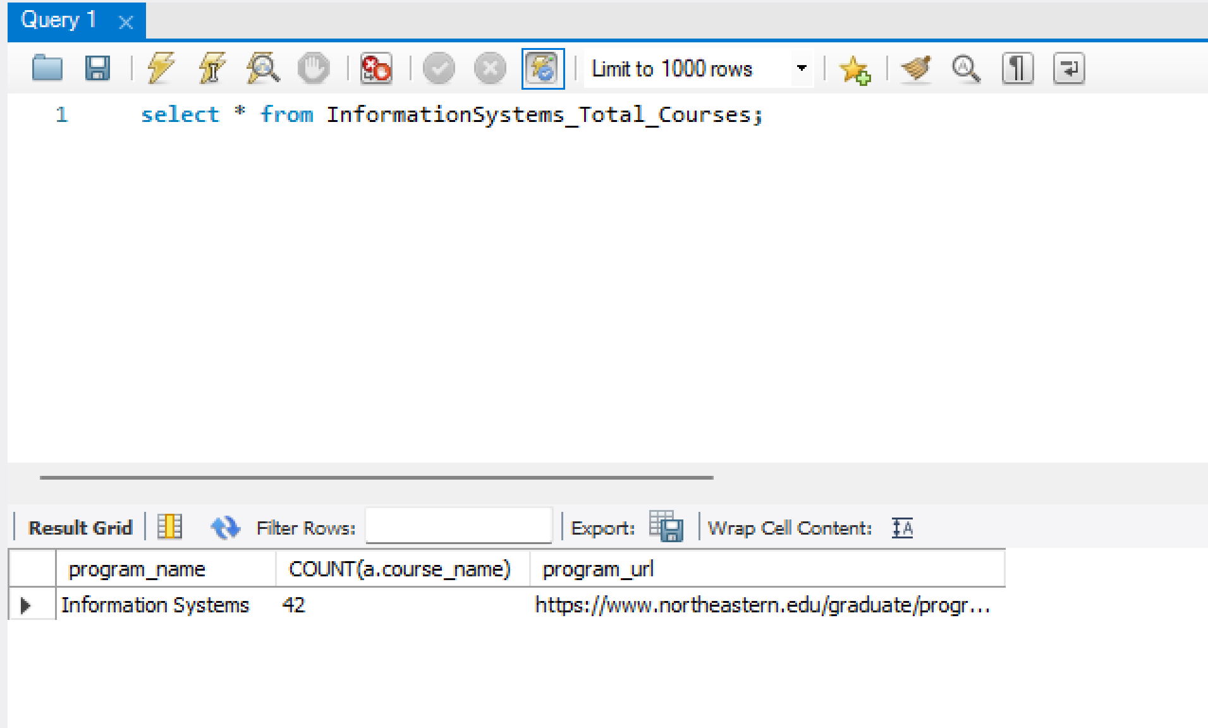

1. Which courses do we need to take to do specialization in User Experience Concentration?

CREATE VIEW User_Experience_Specialization_Courses AS

SELECT a.specialization_name,b.course_id,c.course_name

FROM

neu_specialization a

LEFT JOIN neu_course_specialization b

ON a.specialization_id = b.specialization_id

RIGHT JOIN neu_course_catalog c

ON b.course_id = c.course_id

WHERE a.specialization_name = 'User Experience Concentration';

1. List top rated professors at NEU whose rating is above 4. Also mention the courses and its description taught by the professor.

CREATE VIEW NEU_Top_Rated_Professors AS

SELECT a.faculty_name,a.faculty_rating,b.course_id,c.course_description

FROM neu_facultys a

JOIN neu_course_faculty b

ON a.faculty_name = b.faculty_name

JOIN neu_course_catalog c

ON b.course_id = c.course_id

WHERE a.faculty_rating >= 4;

1. What are the core course requirements for Information Systems, Software Engineering Systems and Data Analytics?

CREATE VIEW Programs_Core_Course_requirement AS

SELECT a.program_name, GROUP_CONCAT(a.course_id SEPARATOR '|'),

COUNT(a.course_id), b.program_url

FROM Course_Core_requirement a

LEFT JOIN NEU_Program b

ON a.program_name = b.program_name

GROUP BY a.program_name;

1. List courses available for Data Analytics Engineering along with its course_outcome.

CREATE VIEW Data_Analytics_course_outcome AS

SELECT

program_name, course_id,course_name, course_description

FROM

NEU_Course_Catalog

WHERE program_name = 'Data Analytics Engineering';

### What is the average overall rating given by students to a professor for a given course?

Create VIEW Professor_Avg_rating AS

SELECT faculty_name, round (AVG(faculty_rating),1) as Average_rating

FROM neu_Facultys

GROUP BY faculty_name;

1. Which courses students need to take to do specialization in Big Data Systems concentration and which resources are available for them?

CREATE VIEW Big_data_Course_Resource AS

SELECT a.specialization_name, b.course_id,c.course_name,d.software_name,e.online_platform

FROM neu_specialization a

LEFT JOIN neu_course_specialization b

ON a.specialization_id = b.specialization_id

LEFT JOIN neu_course_catalog c

ON b.course_id = c.course_id

LEFT JOIN neu_course_resource d

ON c.course_id = d.course_id

LEFT JOIN neu_resource_materials e

ON d.software_name = e.software_name

WHERE a.specialization_name like '%Big Data%';

1. Which job positions are available for students in Data Analytics Engineering and list the details related to those positions?

CREATE VIEW Data_Analytics_Job_Positions AS

SELECT b.program_name, a.job_id,a.title,a.company_name,a.description,a.location

FROM program_jobs b

LEFT JOIN job_info a

ON a.job_id = b.job_id

WHERE b.program_name LIKE '%Data%';

1. Which professors teach courses related to User Experience and list the ratings given by students for the course?

CREATE VIEW User_Experience_Professors AS

SELECT a.specialization_name, b.course_id,c.program_name, d.faculty_name,e.faculty_rating

FROM neu_specialization a

LEFT JOIN neu_course_specialization b

ON a.specialization_id = b.specialization_id

LEFT JOIN neu_course_catalog c

ON b.course_id = c.course_id

LEFT JOIN neu_course_faculty d

ON d.course_id = c.course_id

LEFT JOIN neu_facultys e

ON e.faculty_name = d.faculty_name

WHERE a.specialization_name like '%User%';

1. Find the average course rating for Information Systems Program

CREATE VIEW Information_System_Avg_Course_rating AS

SELECT a.program_name, AVG(b.course_rating)

FROM neu_course_catalog a

RIGHT JOIN neu_course_resource b

ON a.course_id = b.course_id

WHERE a.program_name ='Information Systems';

1. List courses with lowest rating.

CREATE VIEW Lowest_Rating_Courses As

SELECT a.course_id, a.course_name,a.course_description,b.course_rating

FROM neu_course_catalog a

LEFT JOIN neu_course_resource b

ON a.course_id = b.course_id

WHERE b.course_rating = (select min(course_rating) from neu_course_resource);

1. . Find the professors who taught DAMG 7350, INFO 5100, DAMG 6105, DAMG 7275 courses.

CREATE VIEW Professor_DAMG7350_INFO5100_DAMG6105_DAMG7275 AS

select a.faculty_name, b.course_id

from neu_facultys a

JOIN NEU_Course_faculty b

ON a.faculty_name = b.faculty_name

where b.course_id IN ('DAMG 7350', 'INFO 5100','DAMG 6105' ,'DAMG 7275');

1. Which resources are available for students who have chosen Information Systems

program?

CREATE VIEW Information_Systems_Resource_Details AS

SELECT a.program_name,a.course_id,b.software_name,

c.software_download_url,c.online_platform

FROM neu_course_catalog a

JOIN neu_course_resource b

ON a.course_id = b.course_id

JOIN neu_resource_materials c

ON b.software_name = c.software_name

WHERE a.program_name = 'Information Systems';

